This term, we launched our whole school project Our World – Our School, which focuses on a different part of the world each term. This term, our focus was South Asia.
The project began with a short introductory PowerPoint presentation for all year groups, from Reception to Year 6.

Pupils from South Asian backgrounds were invited to prepare and present talks about their personal experiences. Some children presented independently, while others were accompanied by their parents. Several parents also contributed by preparing traditional South Asian food to share with the children.
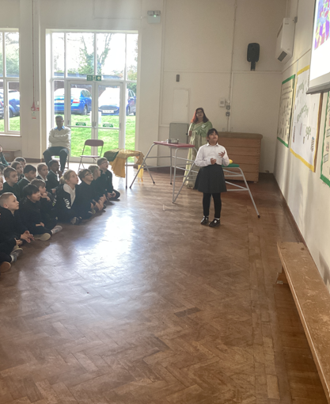
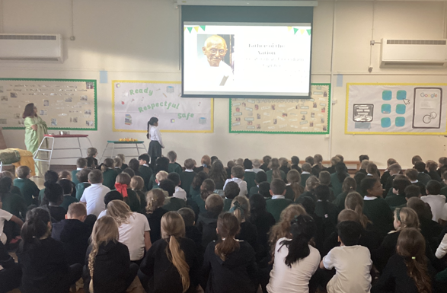
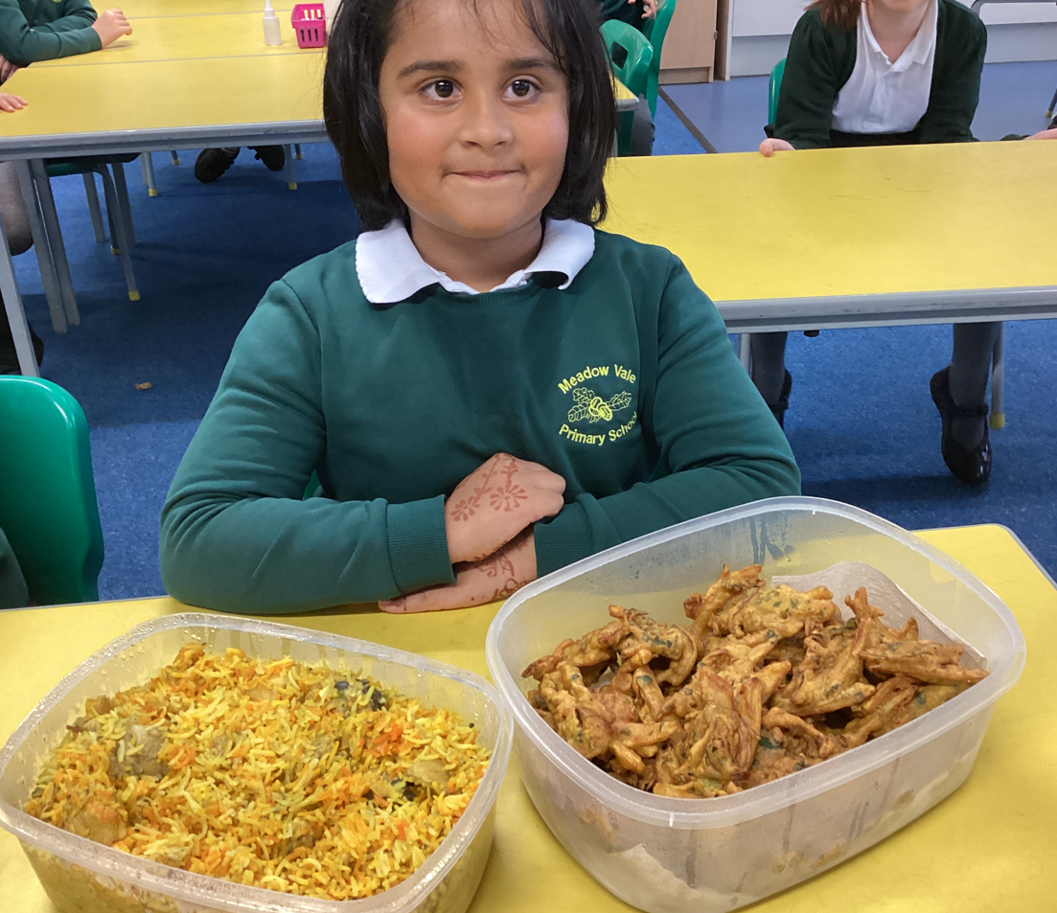
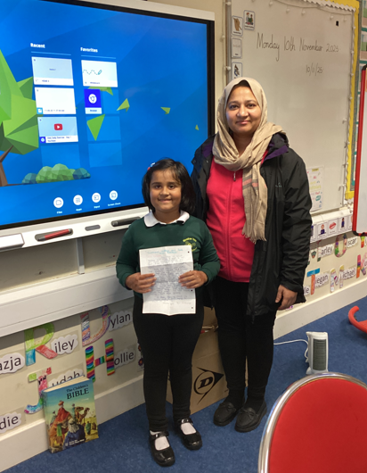

Some staff also did assemblies on their experiences.

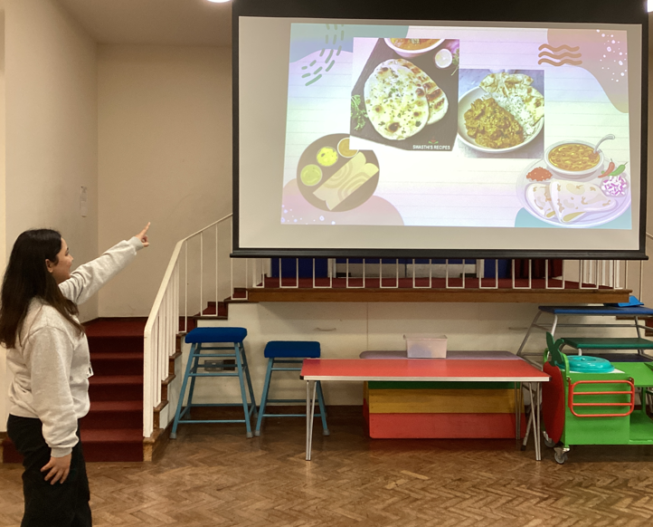

To enrich the experience, a range of activities were offered:
- A Bollywood fitness workshop was held for children in Years 3, 4, 5, and 6.
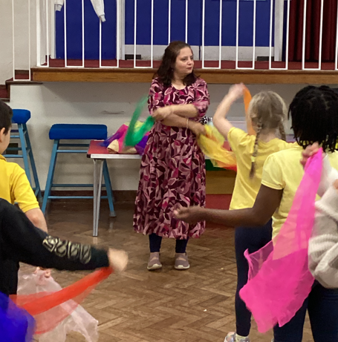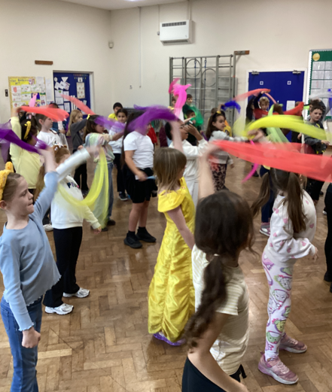

- A professional Henna artist visited school on multiple occasions, allowing children to explore this creative aspect of South Asian culture.
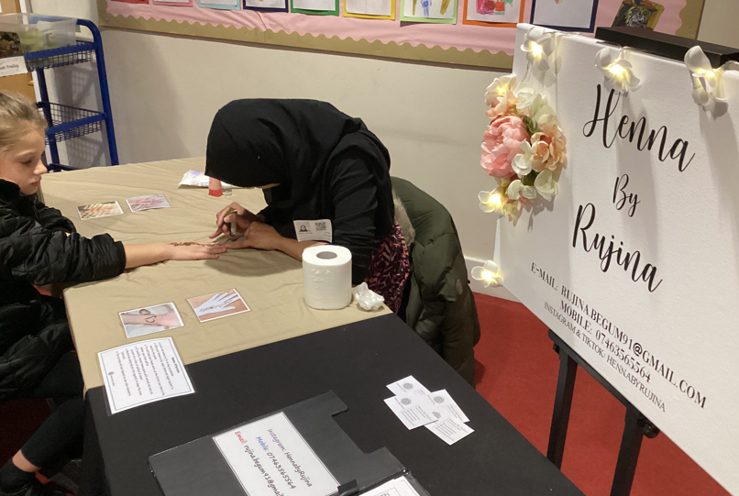
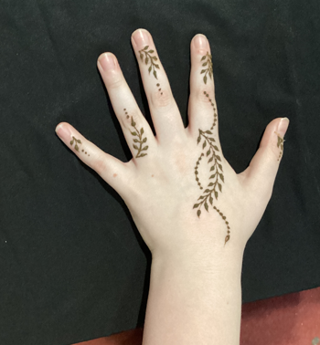

- A local South Asian restaurant visited twice to provide children with the opportunity to taste authentic South Asian dishes.
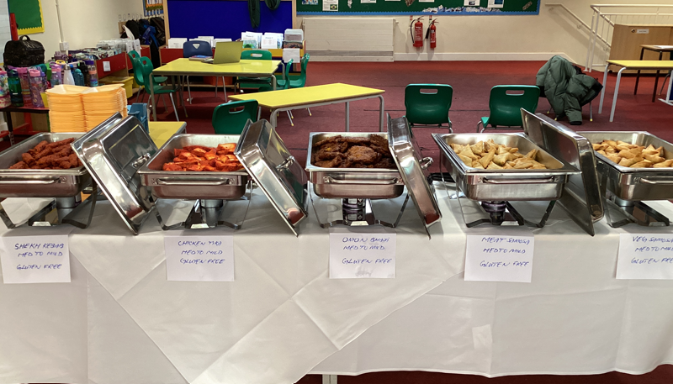

- We had a non-uniform day. children and staff were encouraged to wear traditional South Asian clothing or the colours of a South Asian country’s flag. Many staff also held cookery lessons, teaching pupils to prepare simple yet tasty South Asian dishes.
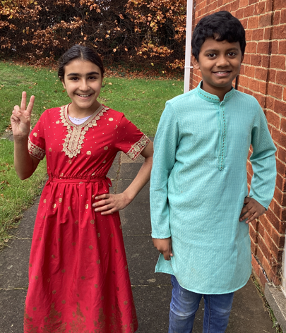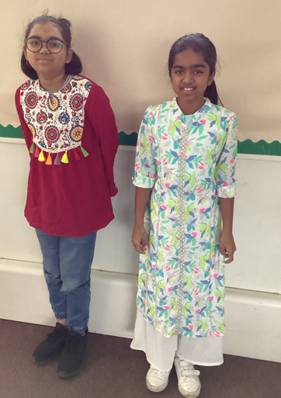
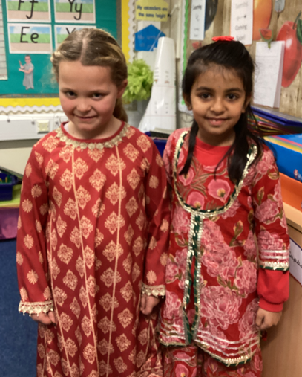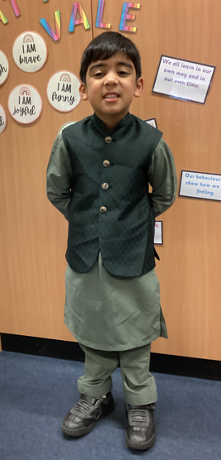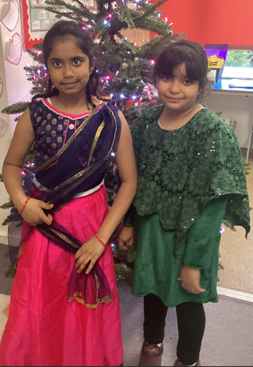
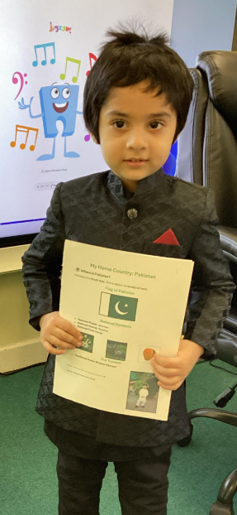
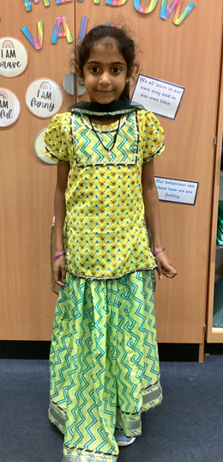
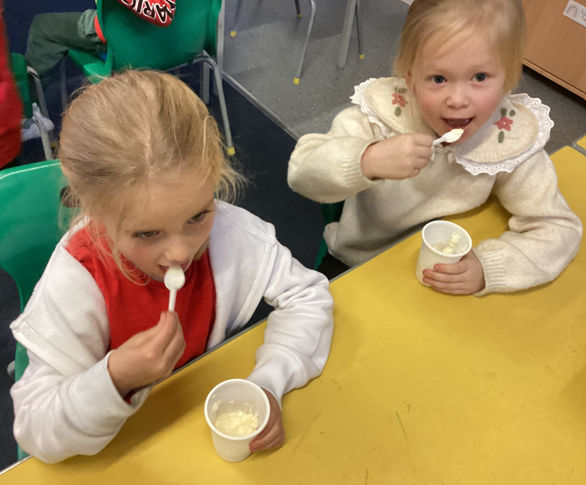

- Staff engagement was strong: colleagues from South Asian backgrounds hosted a traditional tea in the staffroom, and during one inset day, all teachers enjoyed a South Asian lunch together.
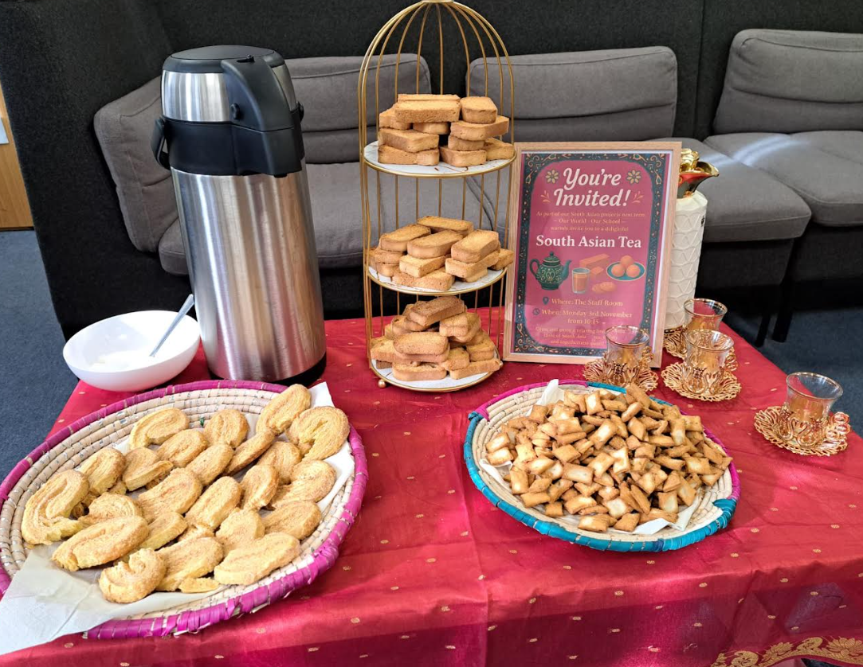
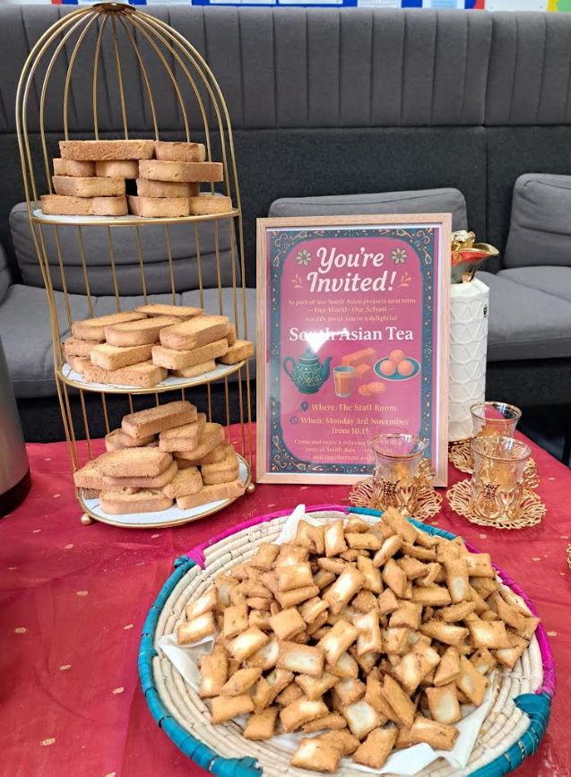

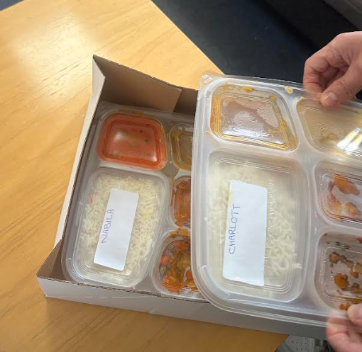

- The language of the term was Urdu and this was introduced to each class by the International Ambassadors.

The project has offered children and staff a rich and immersive experience of South Asian culture, promoting cultural understanding, creativity, and community participation across the school.

If you would like to help out with future projects, please email Mrs Qureshi through the office.

Upcoming projects:
- Rwanda and African countries in the same region
- Saint Georges Day
- Kenya
- International week (celebrating all countries and cultures)
Please also email the office with any ideas for future projects.

Thank you for your support
Mrs Qureshi

