In July, we celebrated our International Week, a joyful event filled with music, dance, food, and colourful traditional clothing that showcased our school’s rich and diverse culture. Throughout the week, the children learned about dances from around the world and were excited to perform their class’s chosen dance.

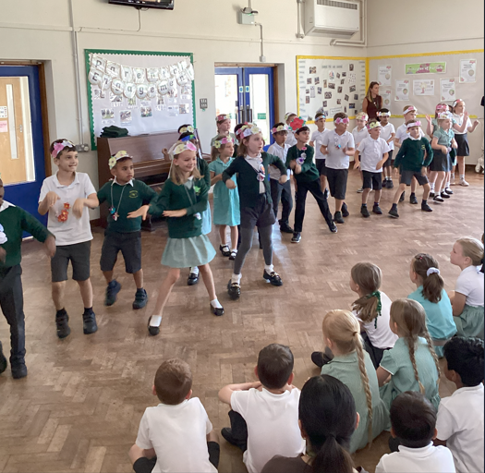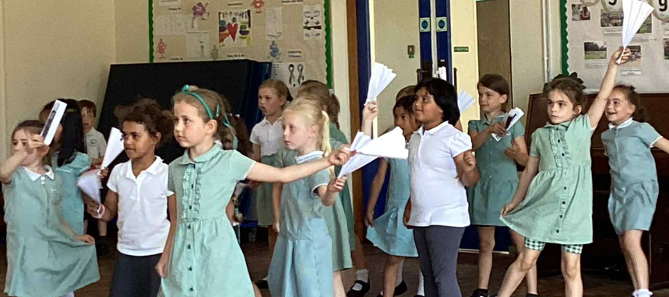
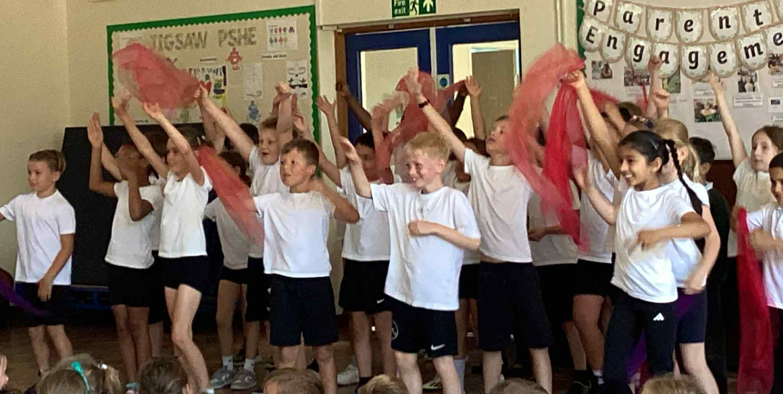

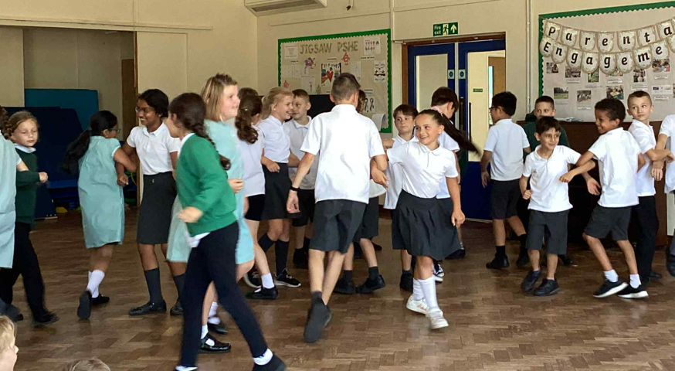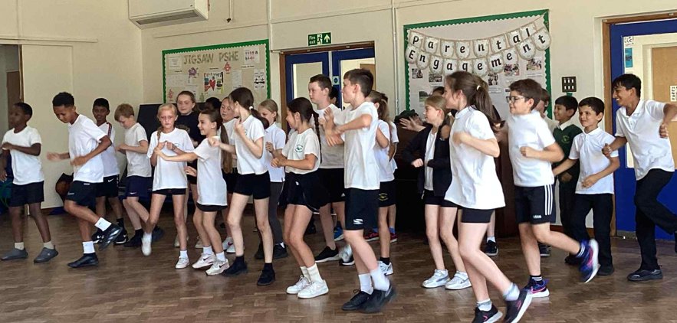

One of the highlights was the children’s parade, where pupils proudly wore traditional clothes from their country of origin and paraded to music from across the globe, a true feast for the eyes and ears.
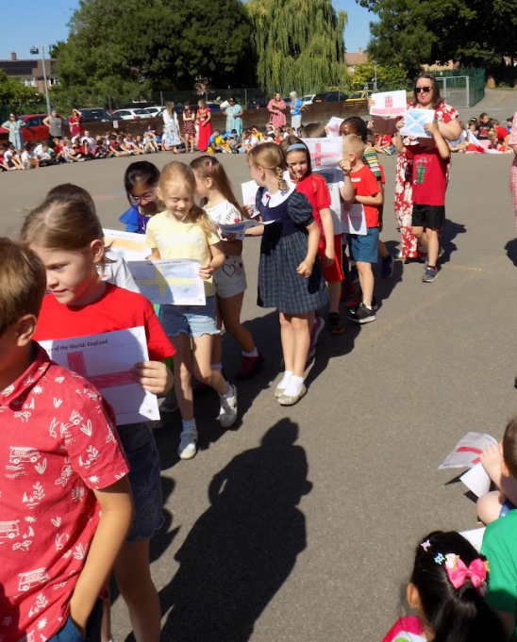
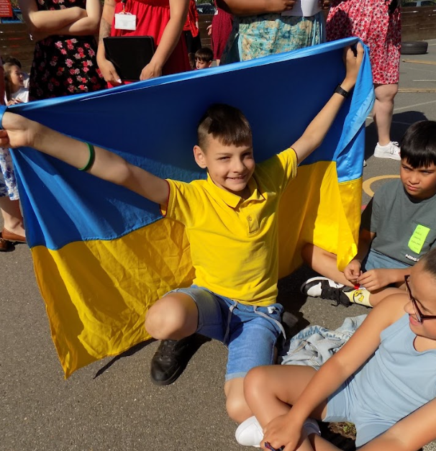
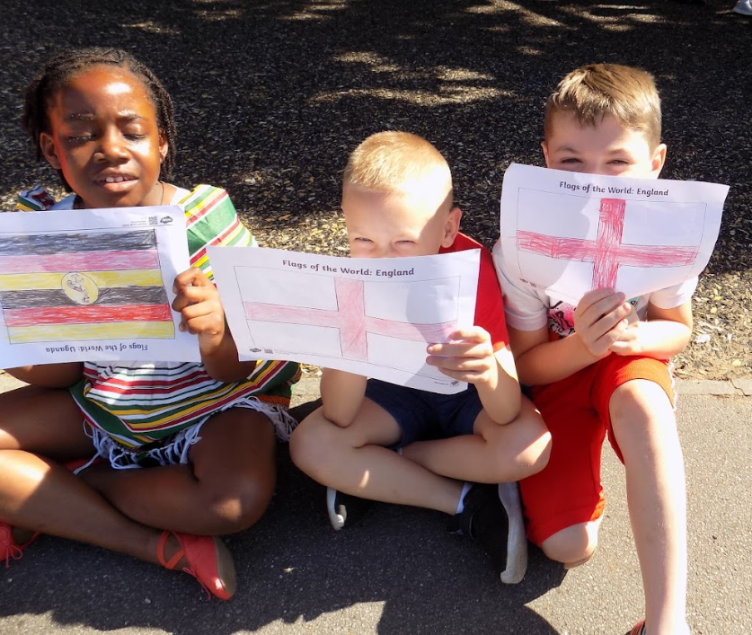
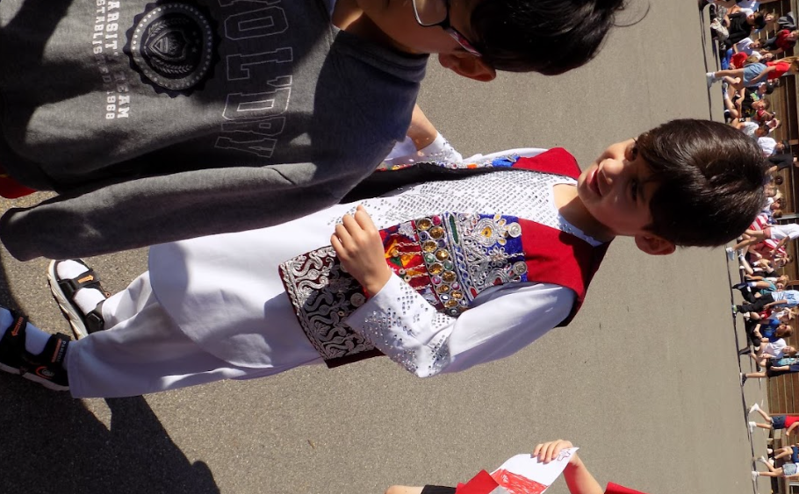

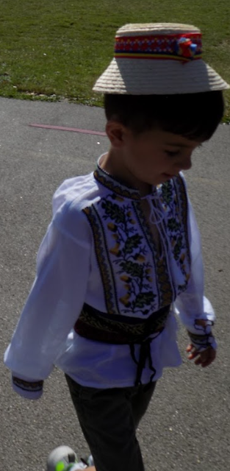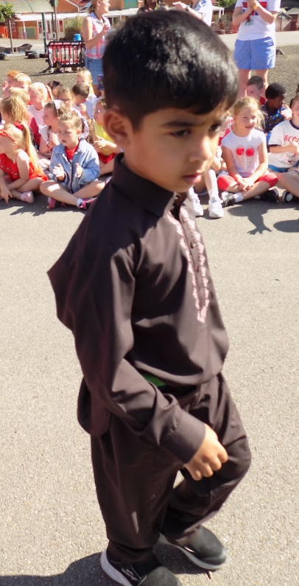
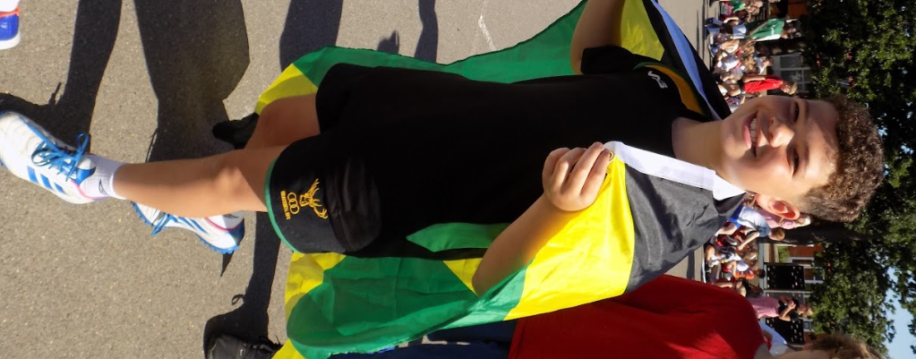

The week ended on a delicious note as families shared dishes from their heritage, giving everyone the chance to taste foods from many different cultures. It was a wonderful celebration of our community, and we hope you enjoy looking through the photos. Thank you for your continued support – we look forward to many more exciting projects this school year!



