Meadow Vale Primary School – Year 1
Topic: Oh To Be Royal | Phase: KS1
Vocabulary
Battlements | The top of the castle wall with raised sections and lowered sections to allow people to fire arrows at their opponents in battle.
Portcullis | A strong iron gate that can be raised to allow the drawbridge to be lowered.
Drawbridge | A bridge that can be lowered or raised to enter and exit a castle.
Moat | A deep ditch that surrounds a castle. It can be filled with or without water.
Turrets | A small tower built on the castle, at the corner or on top of a larger tower.
Keep | Fortified tower built within castles for defence.
Bailey | The outer wall of a castle.
Victorian Age | The period of time in which Queen Victoria was Queen.
Rein | Period of time a Queen or King is in charge.
King Charles III | The countries King today.
Coronation | The ceremony of becoming a King or Queen.

Geography:

2

Objectives for the topic:

1

What should I already know?
Basic knowledge of different fairy tales, being introduced to castles as story settings.

understand geographical similarities and differences through studying the human and physical geography of a small area of the United Kingdom, and of a small area in a contrasting non-European country. Looking at Bangkok.

Use world maps, atlases and globes to identify the United Kingdom and its countries.

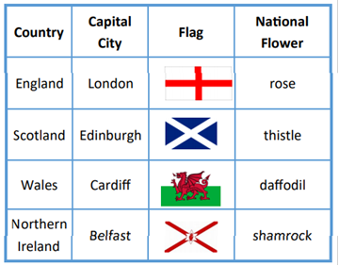

Use aerial photographs and plan perspectives to recognise landmarks and basic human and physical features; devise a simple map; and use and construct basic symbols in a key.

History:

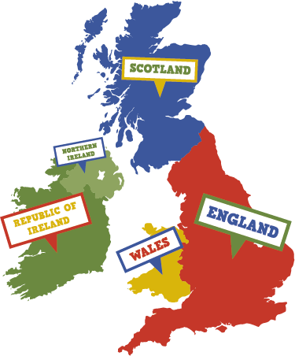
changes within living memory. Where appropriate, these should be used to reveal aspects of change in national life (Looking at the Royal Family)

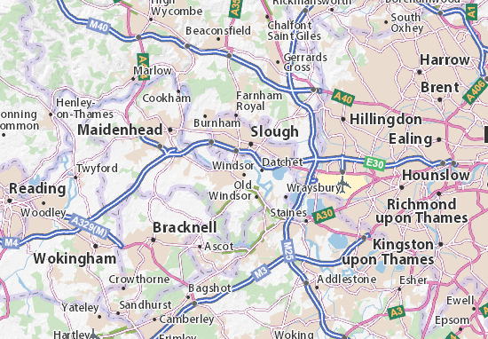
Significant historical events, people and places in their own locality. (Looking at the Queen and Windsor Castle)

The lives of significant individuals in the past who have contributed to national and international achievements. (Queen Victoria)

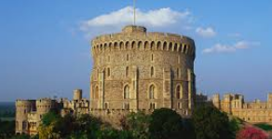
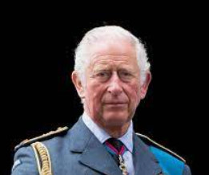
Types of castles
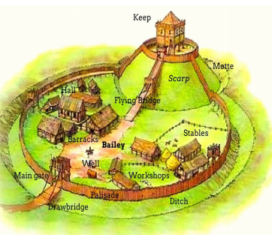

Windsor Castle
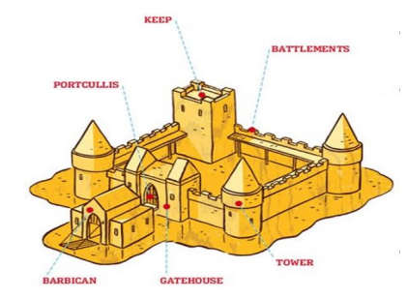
King Charles III
He became King on 8 September 2022
After his mother the Queen (below, left) sadly passed away in Balmoral, Scotland. Aged 73, King Charles III is the oldest monarch ever crowned in British history, having been heir apparent (the next person to be crowned) since he was 3 years old.

Queen Elizabeth II
Queen Victoria
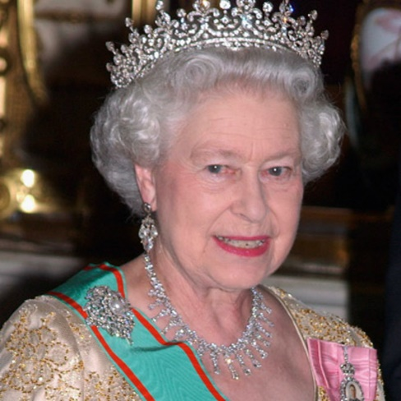
Queen Elizabeth II was born in 1926 in Mayfair, London. Her coronation was on 2nd June 1953 which was watched by a TV audience of 20 million people! She was the longest reigning monarch ever in Britain, even beating her great-grandma Queen Victoria! The Queen had two birthdays: Her actual birthday was on 21st April and her official birthday, which was held on a Saturday in June – when the weather’s better! She died on the 8th Sept 2022

Queen Victoria was born in 1819 at Kensington Palace, London. She became Queen when she was just 18 years old. Her coronation took place at Westminster Abbey where everyone cheered “Long live the Queen!” Queen Victoria was the first member of the Royal family to live at Buckingham Palace.



