Meadow Vale Primary School – Year 1 Science
Topic: Animals including humans | Phase: KS1
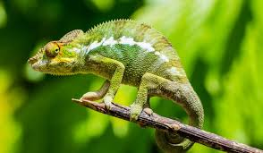
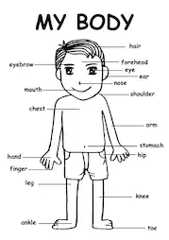
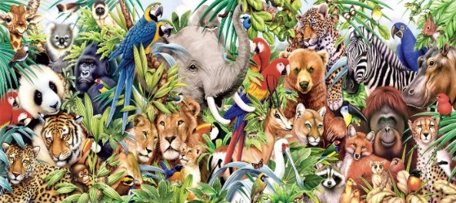
Links to other curriculum areas:
- Art – drawing animal skins and thinking about their different textures.
- PSHE – Healthy Me puzzle.
4

identify, name, draw and label the basic parts of the human body and say which part of the body is associated with each sense.

identify and name a variety of common animals that are carnivores, herbivores and omnivores.

describe and compare the structure of a variety of common animals (fish, amphibians, reptiles, birds and mammals, including pets).

Objectives for the topic:

identify and name a variety of common animals including fish, amphibians, reptiles, birds and mammals.

2

3

Vocabulary
amphibian | They live the first part of their lives in the water and the last part on the land. When they hatch from their eggs, amphibians have gills so they can breathe in the water. They also have fins to help them swim, just like fish.
animal | Animals are living things. ..Unlike plants, which make their own food, animals feed themselves by eating plants or other animals.
bird | An animal with feathers.
body parts | The parts that make up the body.
carnivore | A carnivore is an animal that gets food from killing and eating other animals.
diet | The food and drink that a person or animal usually takes in.
fish | An animal that lives in water and has fins for swimming and gills for breathing. Fish are cold-blooded animals with skeletons inside their bodies.
habitat | A habitat is the home of an animal or a plant.
herbivore | A herbivore is an animal that gets its energy from eating plants, and only plants.
human | A man, woman, child or person. A human being.
mammal | A mammal is an animal that breathes air, has a backbone, and grows hair at some point during its life.
omnivore | An omnivore is a kind of animal that eats either other animals or plants.
reptile | A cold-blooded animal (as a snake, lizard, turtle, or alligator) that breathes air and usually has the skin covered with scales or bony plates.
sense | Senses are touch, smell, taste, sight and hearing.

What should I already know?
- The names of common animals.
- The external parts of the human body.
- The 5 senses.

1

