Meadow Vale Primary School
Topic: Roald Dahl | Subject(s): History | Year: 2
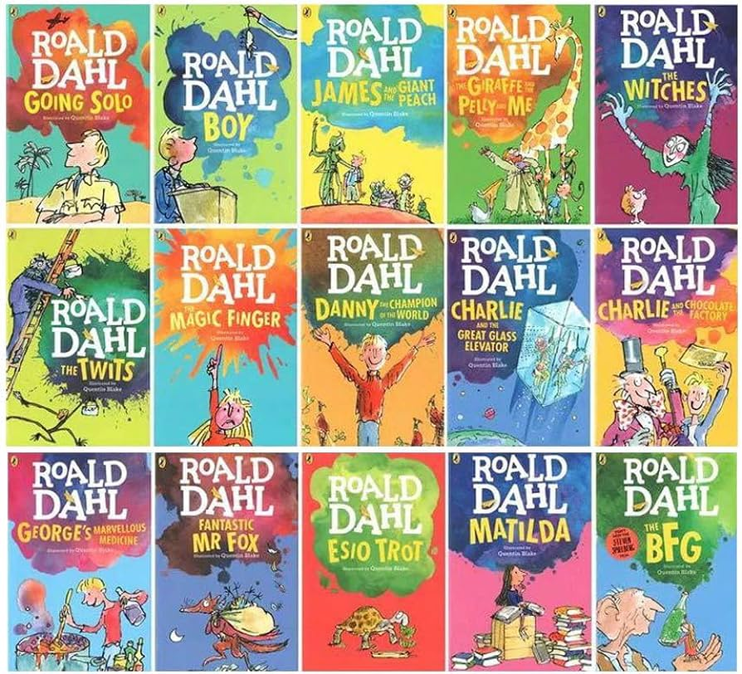
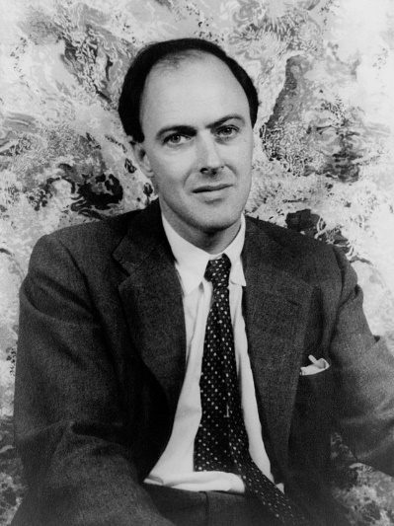
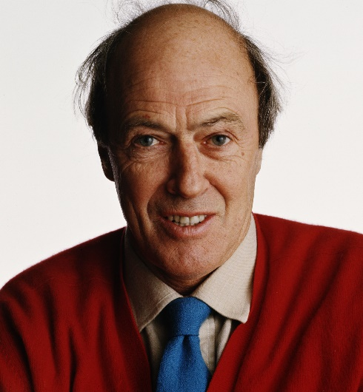

What should I already know?
- Familiar stories from the author through either reading books or watching films.
Key Vocabulary
Historical figure | Historical figures are people who have been important or influential in history.
Autobiography | An account of a person’s life written by that person.
Key Questions and Facts
Who was Roald Dahl? | Roald Dahl is a famous author of children’s books.
How many books did Roald Dahl write? | Roald Dahl wrote approximately 43 books for children.
Who is Quentin Blake? | Quentin Blake is an illustrator known for drawing pictures in Roald Dahl books.

