Meadow Vale Primary School
Topic: World Kitchen | Subject(s): Geography/DT | Year: 2
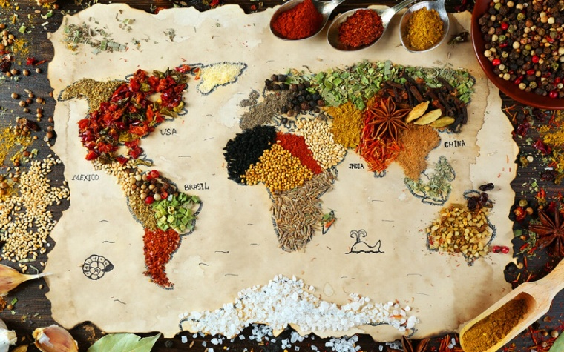
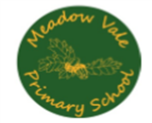
What should I already know?
- The importance of eating the right amounts of different types of food
- The importance of good hygiene when handling/preparing food
- use world maps, atlases and globes to identify various countries, continents and oceans
- use simple compass directions (North, South, East and West)

Key Vocabulary
Cuisine | A cuisine is a style of cooking or food that has certain ingredients and cooking methods. A cuisine is usually linked by a culture or place.
Culture | Many different things make up a culture. These things include food, language, clothing, music, arts, beliefs, and religion. A culture is a pattern of habits of people from an area.
Diet | Sometimes, people think the word diet means ‘eating less’. A diet is a pattern that shows the kinds of food that a person, animal, or community usually eats.
Seasonal food | Seasonal food is linked to the times of year when the harvest or the flavour of a given type food is best. Explore this link: https://www.bbcgoodfood.com/seasonal-calendar/all
Key Questions and Facts
What should I be eating to maintain a healthy diet? | We need to eat to grow, give our body energy and repair itself. A healthy diet is made up of the following food groups: protein, carbohydrates, fruits and vegetables, fats and sugars, dairy and water.
What is Change4Life? | Change4life is an NHS scheme that helps families make better choices about their food, health and fitness. Check out their website: https://www.nhs.uk/change4life
Where does my food come from? | The food we eat every day comes from lots of places and from all around the world. We may buy our food directly from farms, markets, shops or supermarkets. All food that we buy comes from either plants or animals.

Foods we will be making/tasting from around the world
France | Croissant, brioche, pain au chocolat
Italy | Pizza
China | Spring rolls
Greece | Greek salad
India | Curry, naan bread, poppadoms, onion bhajis

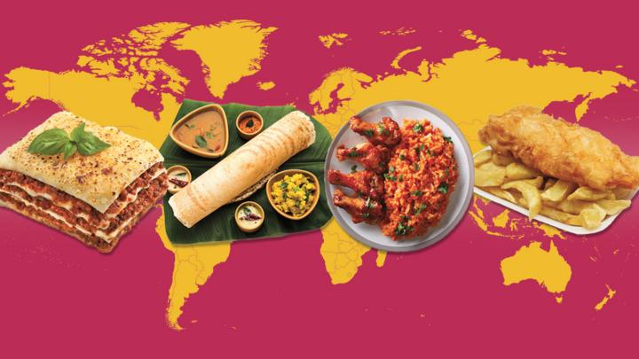
Links to other curriculum areas:
DT – We will understand where food comes from and use the basic principles of a healthy diet to prepare dishes
Science – We will look at the Eatwell plate and find out what we need to be eating to maintain a healthy, balanced diet.

